**LONDON METROPOLITAN UNIVERSITY**

**School of Computing**

**CS6W50 Career Development Learning (CDL)**

**LEARNING LOG**

**Student Londonmet ID: 22085771**

**Student Name: Ronak Krishna Shrestha**

**Student Course: AI**

**CDL Tutor:**

**Place of Work (Company Name): Palm Mind**

DATES OF ENTRIES IN THE LEARNING LOG

|  |  |  |  |
| --- | --- | --- | --- |
| Log Index | Start Date | End Date | Company Supervisor Signature |
| Log 1 | 20th august | 26th august |  |
| Log 2 | 27th august | 4th august |  |
| Log 3 | 5th august | 13th august |  |
| Log 4 | 14th august |  |  |
| Log 5 |  |  |  |
| Log 6 |  |  |  |

**LEARNING LOG 1**

From: 20th august to: 26th august

|  |
| --- |
| **What have I done?**  During this week, I focused on self-learning LangChain and the RAG architecture, enhancing my understanding of these new tools (LO4: Self-Learning and Adaptability to New Tools). I actively participated in daily stand-up meetings with the team, for this week I just explain what I learned from the self-study(LO1: Effective Communication and Collaboration). I also managed to balance my college schedule with my work responsibilities effectively, ensuring that all tasks were completed on time (LO3: Time Management and Prioritization). |
| **What I did well**  I successfully adapted to new tools by dedicating time to study LangChain and the RAG architecture, which improved my knowledge in these areas (LO4). My communication skills were demonstrated through active participation in stand-up meetings, where I provided clear updates and engaged with team members effectively (LO1). I managed my time well by creating a balanced schedule that accommodated both college and work commitments, which helped me meet all deadlines (LO3) |
| **What I could improve on**  I realized that while I was effective in managing my time, I could improve on integrating my new knowledge into practical tasks more quickly. Additionally, I want to work on being more proactive in meetings by suggesting ideas and solutions rather than just reporting updates (LO1, LO3). |
| Action I can take to improve my skills and learning • **Goal:** To integrate my new knowledge of LangChain and RAG architecture into practical tasks more effectively.   * **Action:** Create a mini-project or prototype using LangChain and RAG to apply what I’ve learned. * **Timing:** Complete the prototype by August 25, 2024.   • **Goal:** To enhance my proactive participation in meetings.   * **Action:** Prepare at least two suggestions or ideas for each meeting based on the week’s progress. * **Timing:** Implement this practice in all meetings from August 23, 2024, onward. |

Screenshots Proofs for the Week

* **LO1: Communication Skill:** Screenshot of meeting minutes or Slack messages showing my participation in stand-up meetings.

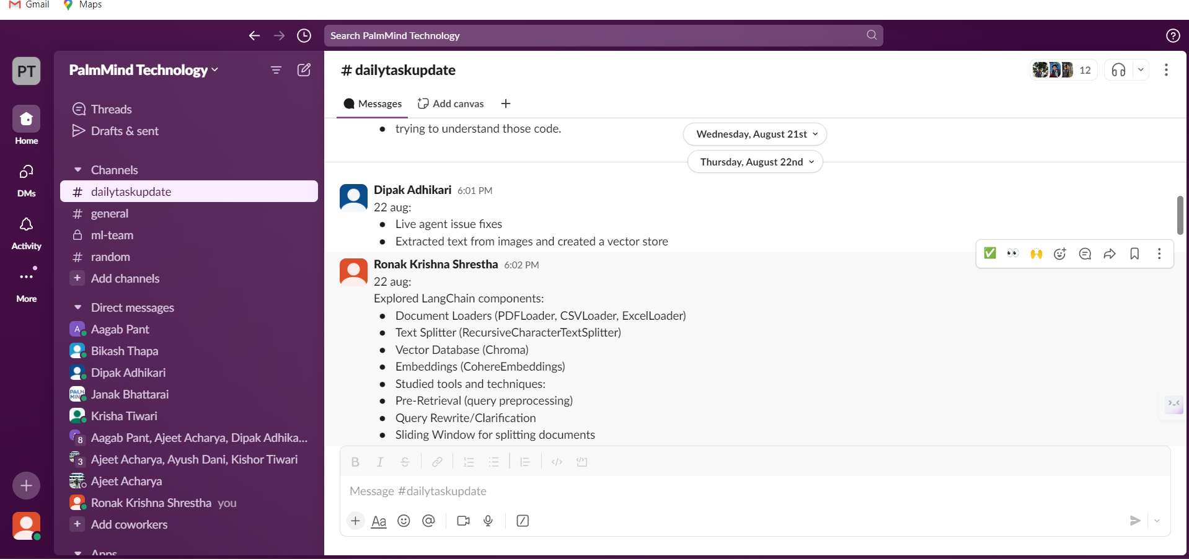

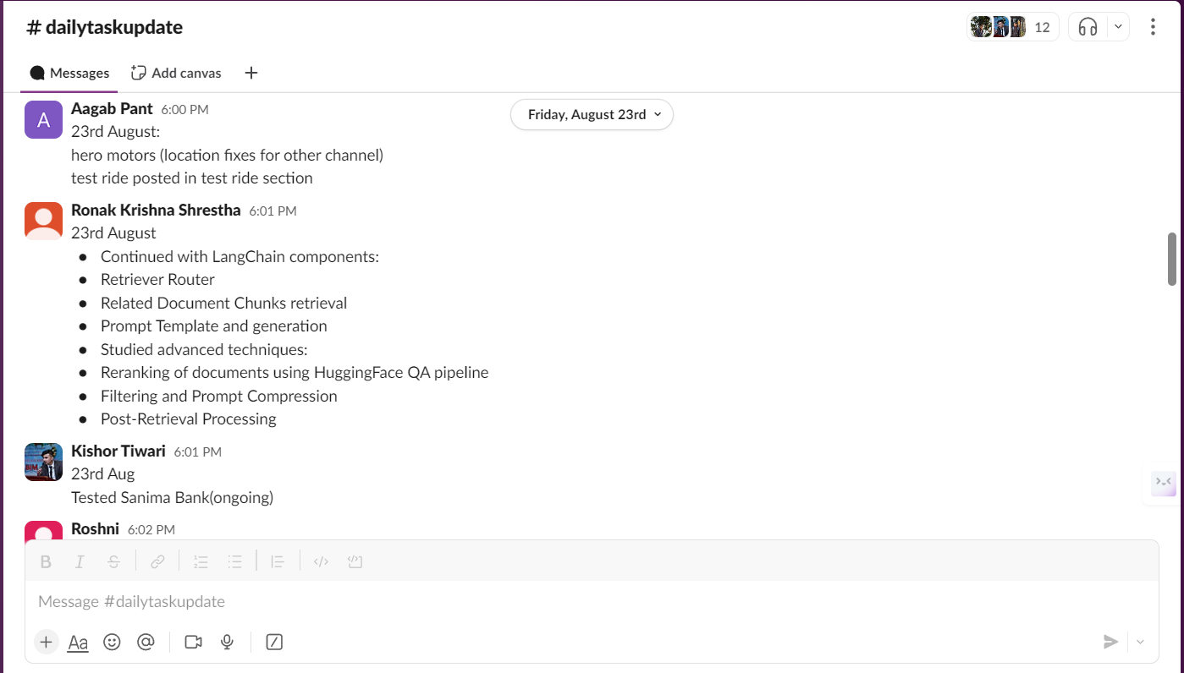

* **LO3: Time Management:** Screenshot of my work and college schedule and attendance
* **LO4: Self-Learning:** Notes or a summary of LangChain and RAG architecture studies.

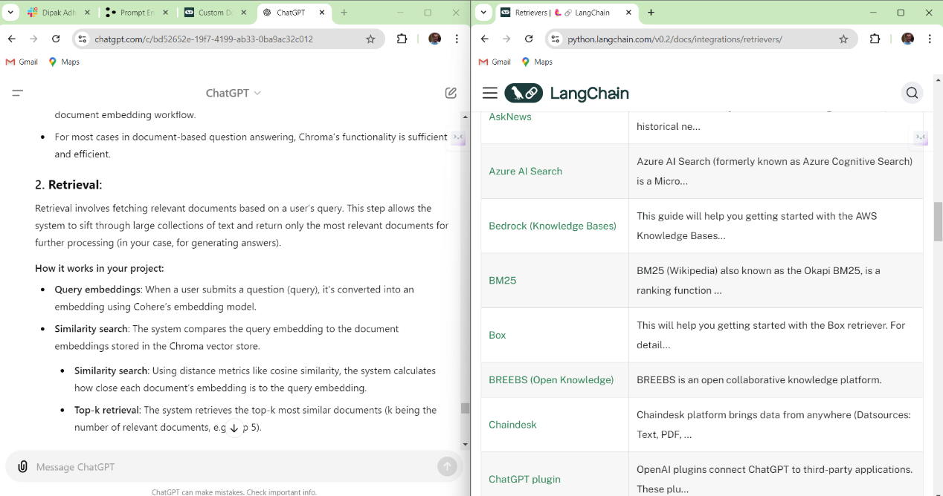

Figure 1: research about retrievals

Figure 2:using hugging face transformer gpt 2.5

Figure 3: output of age being ridiculus

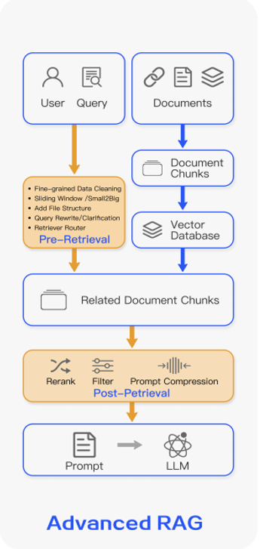

Figure 4: research of advanced rag

**LEARNING LOG 2**

From: 27th august to: 4th September

|  |
| --- |
| **What have I done?**  • **Effective Communication and Collaboration (LO1):** Collaborated effectively with Ajeet Acharya and other team members via Slack and GitHub, providing updates and discussing project details.  • **Critical Thinking and Decision-Making (LO2):** Worked on KMC query testing and bug fixes, applying problem-solving skills to address issues and improve functionality.  • **Data Processing and Management (LO6):** Managed and processed Nepali data for KMC, including vector store setup and data handling.  • **API Integration and Testing (LO8):** Tested and integrated APIs using FastAPI, adapting to new tools and incorporating them into the project.  • **Version Control (Git/GitHub) (LO9):** Utilized Git for version control, managing code changes, resolving conflicts, and collaborating with team members.  • **Vector Databases and Redis Integration (LO10):** Contributed to the setup and management of vector databases and Redis integration, ensuring effective data retrieval and storage. |
| **What I did well**   * **Data Processing and Management (L6):** Successfully created and managed the KMC Nepali data, and set up the vector store, ensuring accurate data preparation for the chatbot. * **Critical Thinking (L2):** Effectively identified and resolved bugs, improving the functionality of the KMC system. * **API Integration (L9):** Conducted API testing on FastAPI, ensuring smooth integration and functionality of the chatbot endpoints. * **Communication and Collaboration (L1):** Maintained clear and effective communication with Ajeet Acharya, which facilitated successful project execution. * **Vector Database creation (L10):** I created both the milvus and chroma database which successfully being retrieved |
| **What I could improve on**   * **Vector Database creation(L10):** Use more structured code to create milvus database such that it will be easier to create, update and delete milvus vector store * **Using Git (L7):** Enhance understanding of Git features, focusing on advanced aspects like resolving merge conflicts and utilizing version control more effectively. |
| Action I can take to improve my skills and learning  * **Goal:** To improve vector database creation efficiency.   + **Action:** Refactor code to create a more structured approach for managing Milvus vector stores, focusing on ease of updates and deletions by September 15, 2024.   + **Timing:** Review and refactor code by September 10, 2024, and test the new approach by September 15, 2024. * **Goal:** To enhance Git proficiency.   + **Action:** Study advanced Git features and practice resolving merge conflicts through online tutorials and exercises by September 12, 2024.   + **Timing:** Complete Git training by September 10, 2024, and apply skills to resolve real conflicts by September 12, 2024. |

Screenshots Proofs for the log 2

• **LO1: Communication:** Slack messages

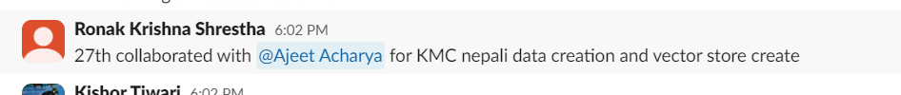

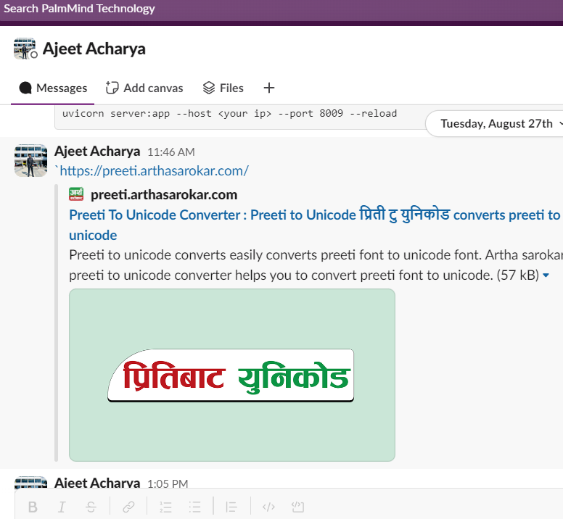

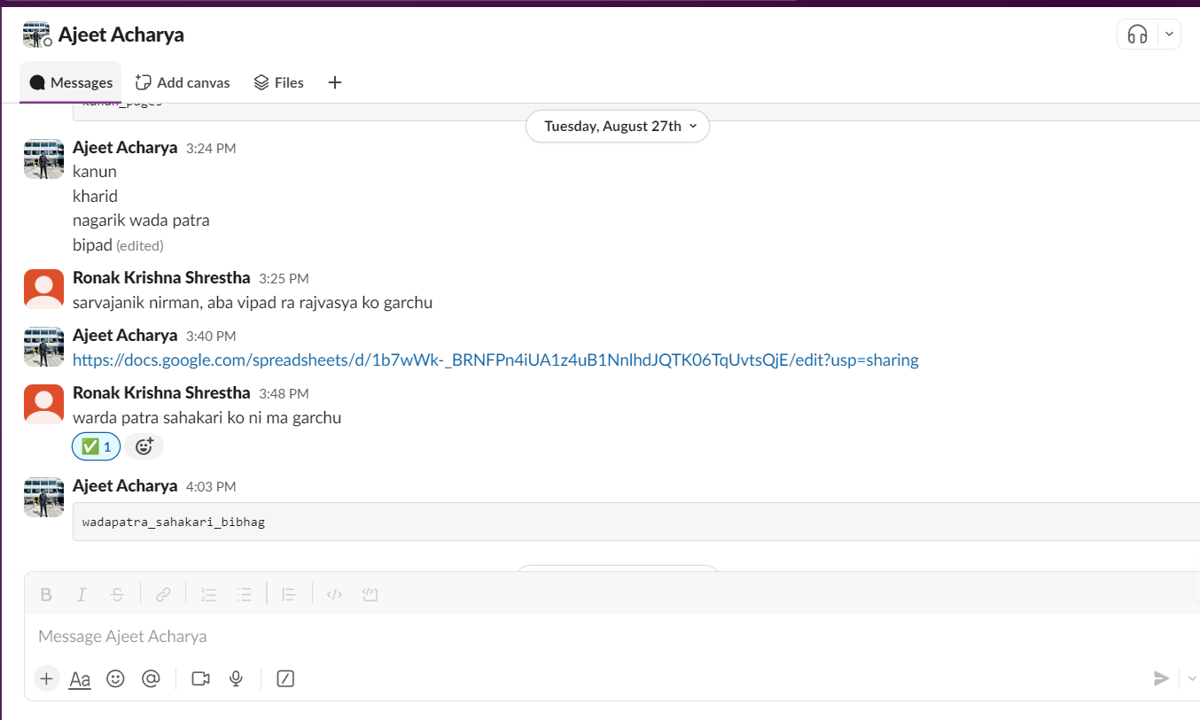

• **LO2: Critical Thinking:** Documentation of bug fixes and query testing results.

Figure 5: same chunks with different pk being returned

Figure 6: performing similarity search

Figure 7: using list and not in function to get unique chunks

• **LO6: Data Processing:** Screenshots of data processing and vector store setup.

• **LO8: API Integration:** API testing documentation and code snippets.

•**LO9: Version Control:** Git commit history and pull request reviews.

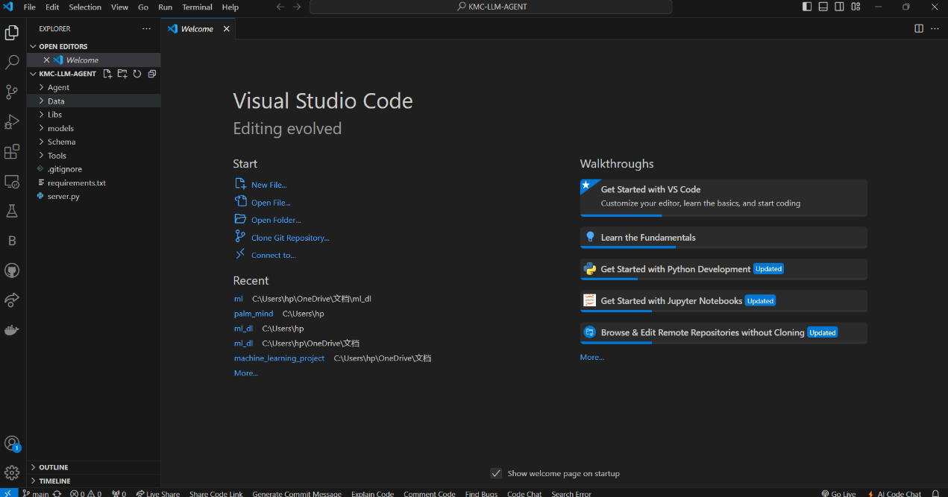

Figure 8: git repo cloned in vs code

Figure 9: git files

Figure 10: git repo

•**LO10: Vector Databases:** Documentation and screenshots of vector database management and Redis integration.

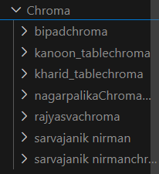

Figure 11: chroma vector store created in local machine

Figure 12: oops approach to create vector store

Figure 13: vector store update code

**LEARNING LOG 3**

From: 5th august to: 12th September

|  |
| --- |
| **What have I done?**  • **QA and Bug Fixes (LO2: Critical Thinking and Decision-Making)**: Addressed and resolved bugs reported by QA, demonstrating problem-solving skills and iterative improvements.  • **Collaboration and Communication (LO1: Effective Communication and Collaboration)**: Worked closely with team members and QA to ensure timely resolution of issues and effective communication through Slack and GitHub.  • **Research on Real-Time Speech (LO4: Self-Learning and Adaptability to New Tools)**: Conducted research on real-time robot speech with minimal delay and natural voice to enhance chatbot capabilities.  • **Data Conversion (LO6: Document and Data Processing)**: Converted FAQ documents from their original format to CSV for improved processing and integration.  • **Prompting Techniques (LO8: Prompt Engineering)**: Applied various prompting techniques to enhance chatbot responses and improve performance.  • **API and Frontend Testing (LO9: API Integration for Testing and Redis Integration)**: Utilized FastAPI for testing and created a local testing link for frontend integration and QA testing.  • **Version Control (LO7: Version Control and Team Collaboration (Git/GitHub))**: Used Git for managing code changes and collaborating with the team effectively. |
| **What I did well**  • **Problem-Solving**: Successfully addressed and fixed bugs identified during QA, which improved the stability and functionality of the application.  • **Collaboration**: Maintained effective communication with team members and QA, ensuring that issues were resolved promptly and collaboratively.  • **Data Processing**: Efficiently converted FAQ documents to CSV format, enhancing data handling and integration processes. |
| **What I could improve on**  • **Real-Time Speech Processing (L4)**: Further research and experimentation needed to optimize real-time speech processing to achieve even lower latency and more natural-sounding speech.  • **Prompt Optimization (L8)**: Enhance the effectiveness of prompts by refining techniques and incorporating more advanced methods for better response accuracy. |
| Action I can take to improve my skills and learning • **Real-Time Speech Processing**: Research and test additional real-time speech processing techniques by the end of the next week (19th September). Document findings and implement improvements in the project.  • **Prompt Optimization**: Review and refine prompt engineering techniques within the next two weeks (19th September). Create and test new prompt strategies to improve response accuracy and document changes. |

**Screenshots Proofs for the Log 3**

* **QA and Bug Fixes (LO2)**: Attach screenshots or logs showing bug fixes and QA feedback.

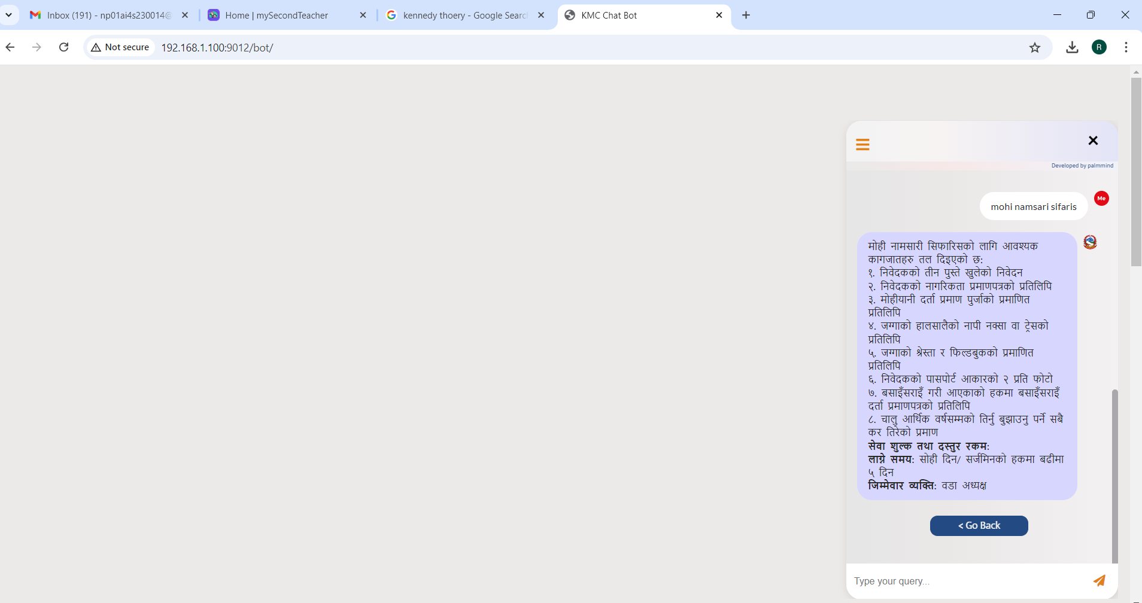

* **Collaboration (LO1)**: Include Slack messages and GitHub commit history demonstrating collaboration and communication

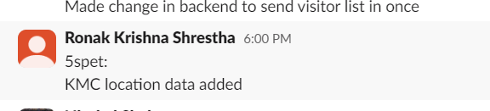

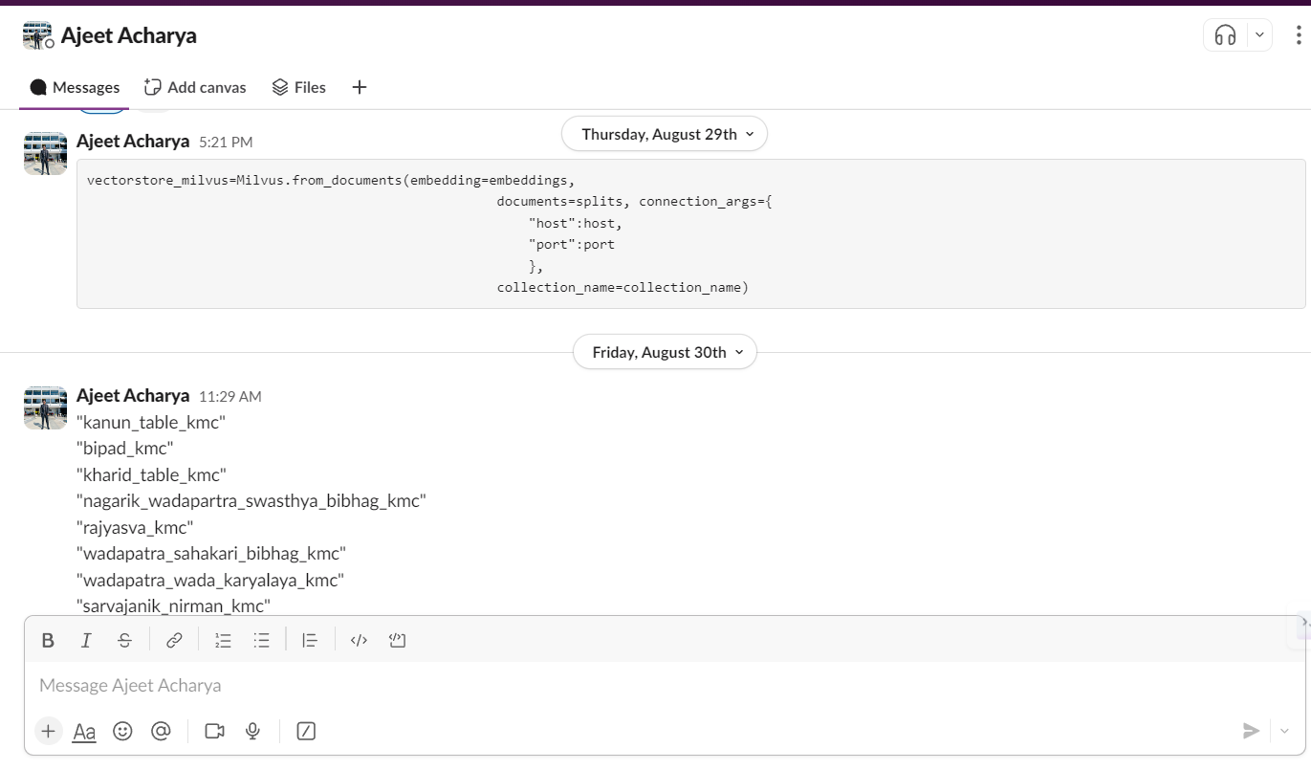

* **Data Conversion (LO6)**: Provide before-and-after screenshots of FAQ documents and CSV files.

* **API and Frontend Testing (LO9)**: Include screenshots of the local testing environment and API responses.



**LO7: Version Control and Team Collaboration (Git/GitHub)**

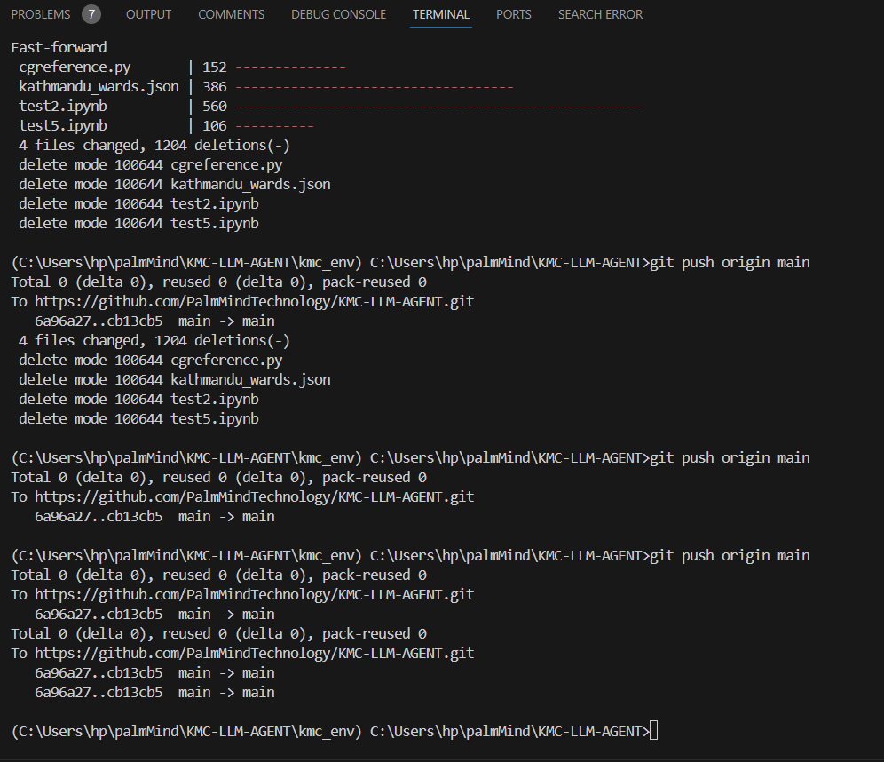

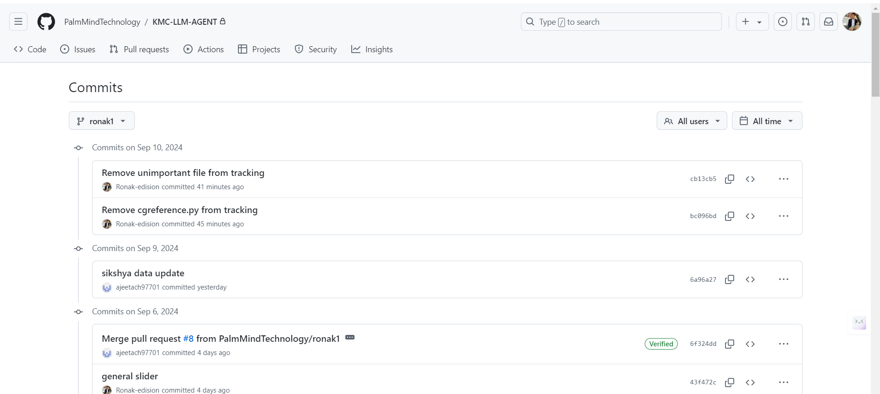

**LO4: Self-Learning and Adaptability to New Tools**

**LEARNING LOG 4**

From: 14th august to:

|  |
| --- |
| **What have I done?** |
| **What I did well**  • |
| **What I could improve on** |
| Action I can take to improve my skills and learning |

**Screenshots Proofs for the Log 3**